Name:

ID:

M2 Assignment C1-05

Submit assignment here: <https://docs.google.com/forms/d/e/1FAIpQLSchfqxytILjYVPTFGTgpN456aYRrcNuI3v7j6hG2Gc-Wm1yWw/viewform>

JSFiddle: <https://jsfiddle.net/>

Book: <http://runestone.academy/runestone/books/published/webfundamentals/CSS/toctree.html>

Part 1A: [Color Theory](https://www.w3schools.com/colors/colors_theory.asp)

1. Newton said colors are mixtures of which 3 kinds of light?

|  |  |
| --- | --- |
| Blue, orange, purple | Cyan, magenta, yellow |
| Black, white, gray | Green, blue, red |
| Red, blue, yellow | Blue, yellow, black |

1. Consider the following:

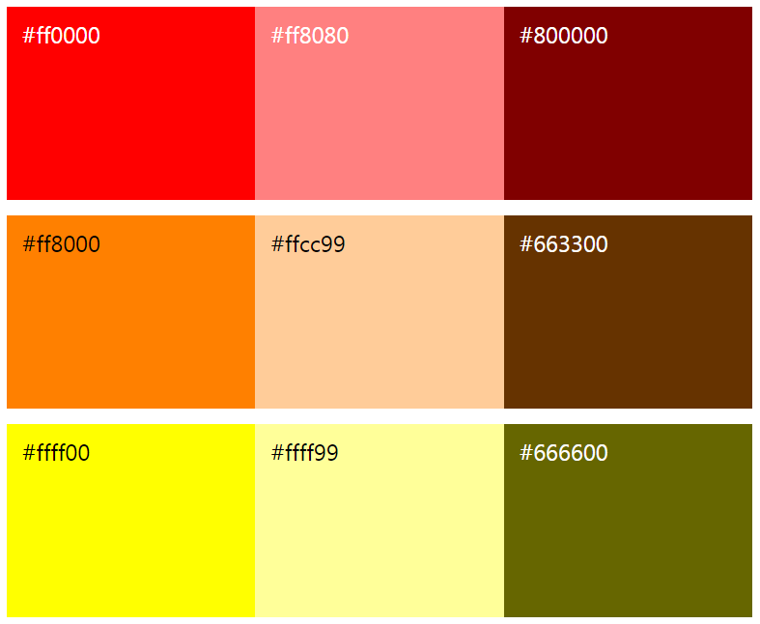

Which of the following has the same **hue** but different **darkness** than #ff0000?

|  |  |
| --- | --- |
| #ff8000 | #666600 |
| #800000 | #ff8080 |
| #ffcc99 | #663300 |

Part 1B: [Color Psychology](https://www.w3schools.com/colors/colors_psychology.asp)

1. Which color will most likely attract attention:

|  |  |
| --- | --- |
| Red | Blue |
| Green | Purple |
| Yellow | Brown |

1. All of the following are true of color except what?

|  |  |
| --- | --- |
| Influence taste of food | Influence attractiveness |
| Influence human behavior | Influence human height |

1. Which color should a spa use as the background color of their website? They want their users to feel *safe*, *calm*, and *fresh*.

|  |  |
| --- | --- |
| Black | Gray |
| Yellow | Green |
| Blue | Pink |

Part 1C: [HTML](https://www.w3schools.com/html/default.asp) and CSS

1. Which of the following lines of HTML creates a paragraph tag with 3 classes?

|  |  |
| --- | --- |
| <paragraph class=3></paragraph> | <p class=”3”></p> |
| <p class=”abc”></p> | <paragraph id=”he” class=”abc”></paragraph> |
| <p class=”a1 b c” id=”sam”></p> | <paragraph c1=”h” c2=”a” c3=”d”></paragraph> |

1. How many *h2* elements will have skyblue text color?

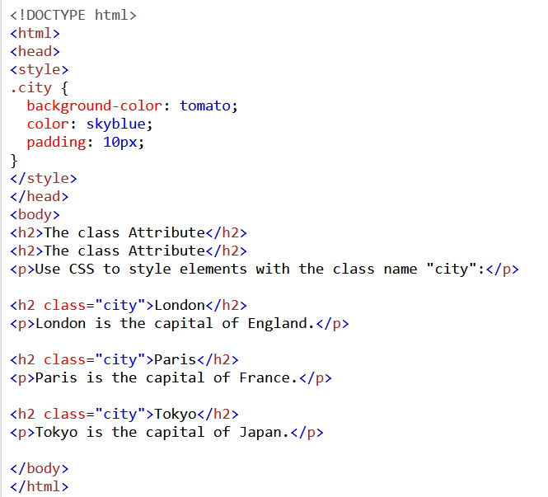

|  |  |
| --- | --- |
| 1 | 2 |
| 3 | 4 |
| 5 | 0 |

1. Which of the following is false in regards to classes in HTML?

|  |  |
| --- | --- |
| The class “city” is the same as the class “City” | The class “a1” is different than the id “a1” |
| An HTML element can have multiple classes | The class “head” id different than the tag <head></head> |

1. The text “CAT” will be which color?

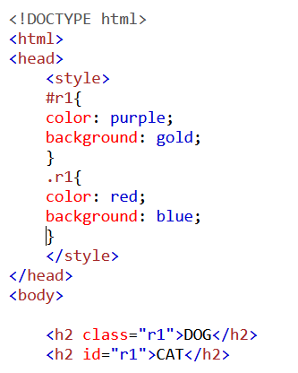

|  |  |
| --- | --- |
| black | gold |
| purple | white |
| red | blue |

1. Which of the following is not an HTML heading tag?

|  |  |
| --- | --- |
| h1 | h5 |
| h9 | h4 |
| H6 | h2 |

1. Which of the following correctly adds inline-css to style the color of an h1 blue?

|  |  |
| --- | --- |
| <h1 style="color:blue;">This is a heading</h1> | <h1 style="h1{color:blue;}">This is a heading</h1> |
| <h1 style="background:blue;">This is a heading</h1> | <h1 color:blue;">This is a heading</h1> |
| <h1 style="text-color:blue;">This is a heading</h1> | <h1 style="font-color:blue;">This is a heading</h1> |

1. Which CSS rule applies a margin of 50px to all 4 sides of an HTML table?

|  |  |
| --- | --- |
| th {margin: 50px;} | td {margin: 50px 50px 0px;} |
| table {margin: 0px 50px;} | table {margin-top: 50px;} |
| table {margin: 50px;} | table {padding: 50px;} |

Part 1D: [JavaScript](https://www.w3schools.com/js/default.asp)

1. What is the output of the following JavaScript?

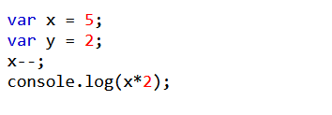

|  |  |
| --- | --- |
| 5 | 10 |
| 4 | 14 |
| 6 | 8 |

1. Consider the following code:

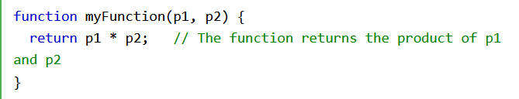

What is the output of myFunction(12,12)

|  |  |
| --- | --- |
| 12 | 12,12 |
| 3 | 24 |
| myFunction(12,12) | 144 |

Part 2: Applications

1. Create the following with HTML and CSS. Paste your code below:

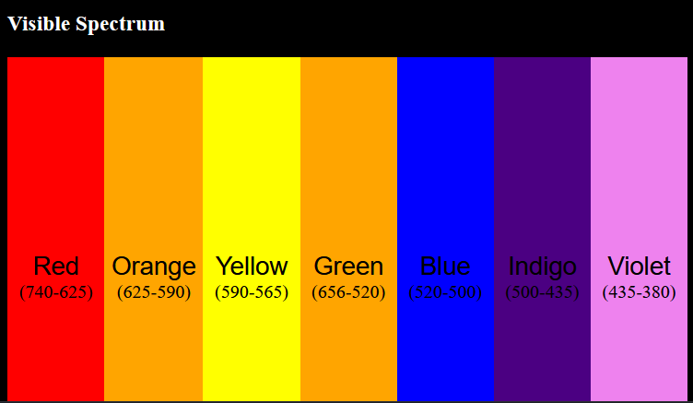

1. Create an unordered list (<ul>) with 3 list items (<li>). The first item should be a hyperlink (<a>) to a website that you like, the second item should be an image (<img>), and the third should be a heading (<h1>) saying your name.